Web Portal URL - <https://localhost:44399/>

API Portal URL - <https://localhost:44331/>

**User View**

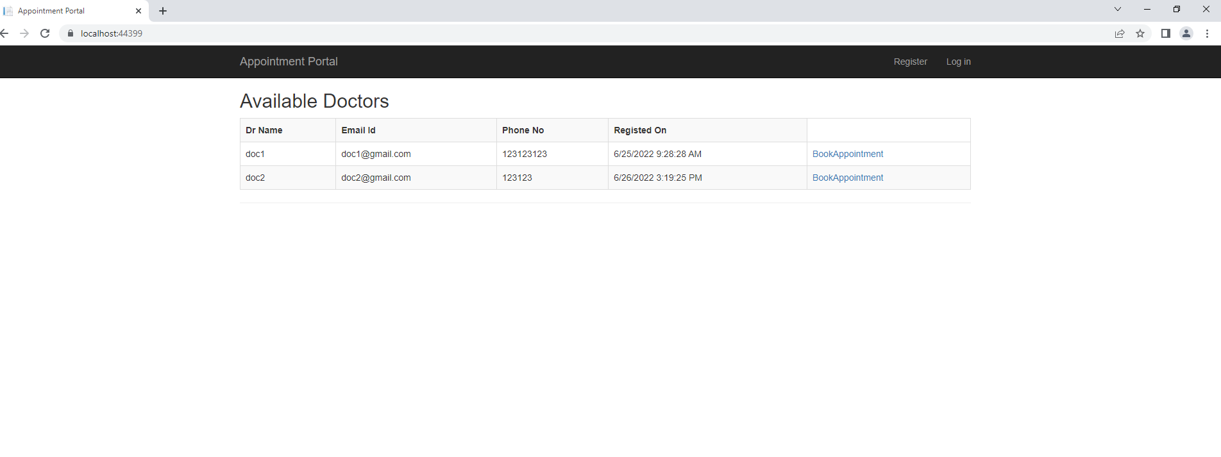

**Booking View**

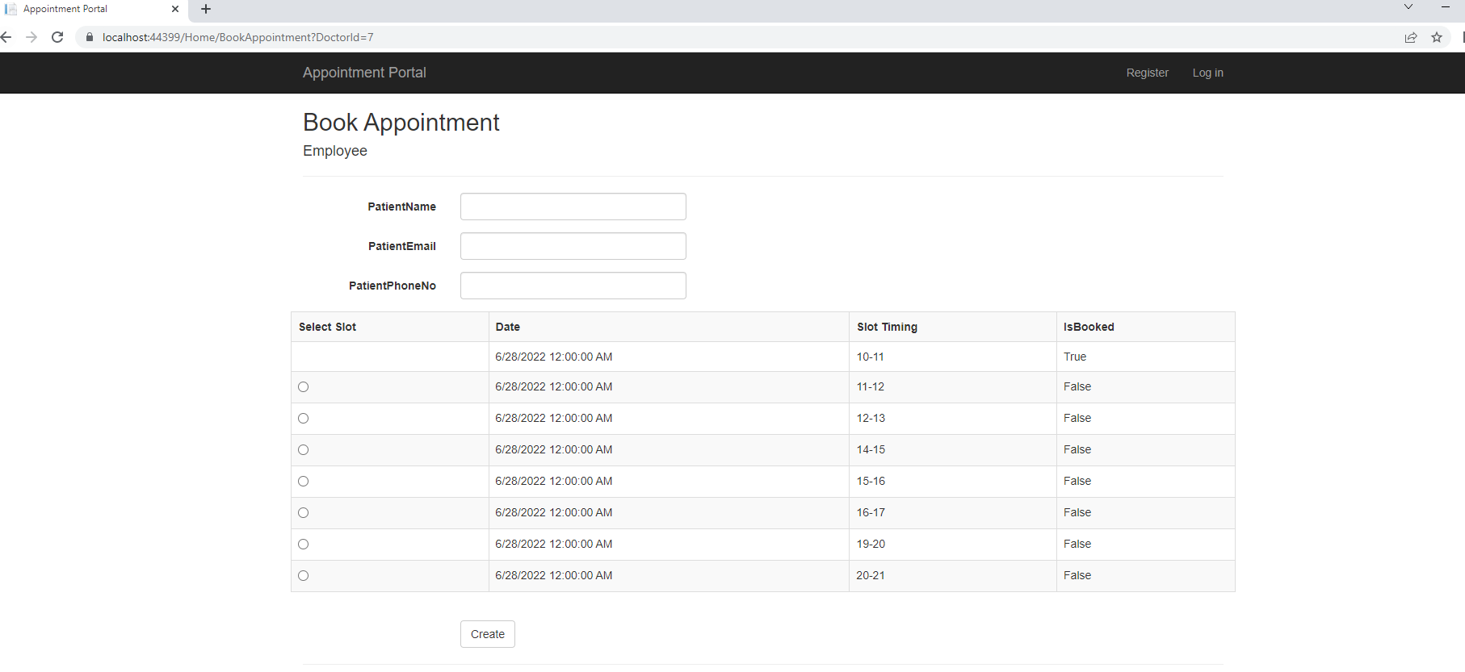

**Doctor Register**

D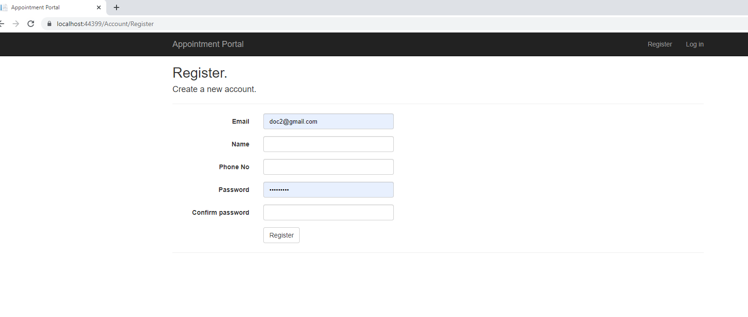

**Doctor Login**

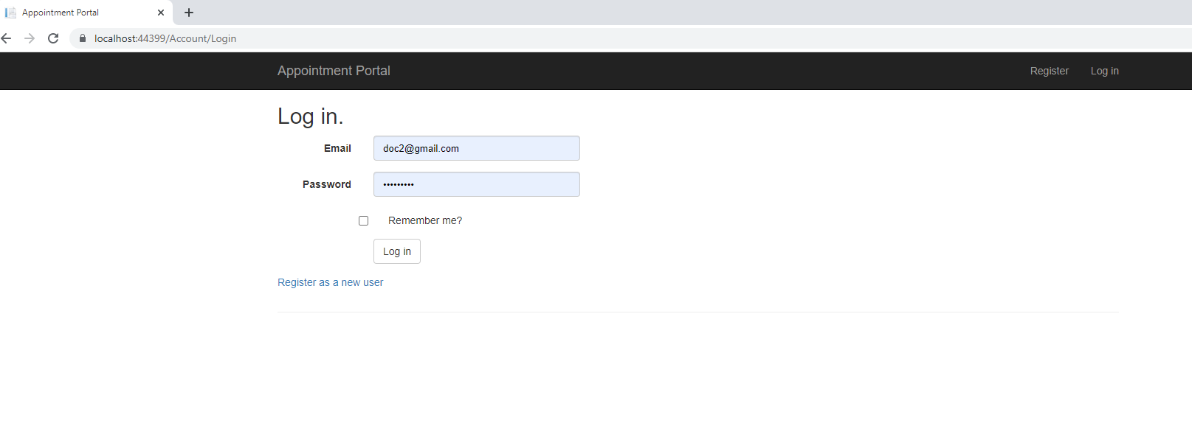

**Doctor Dashboard**

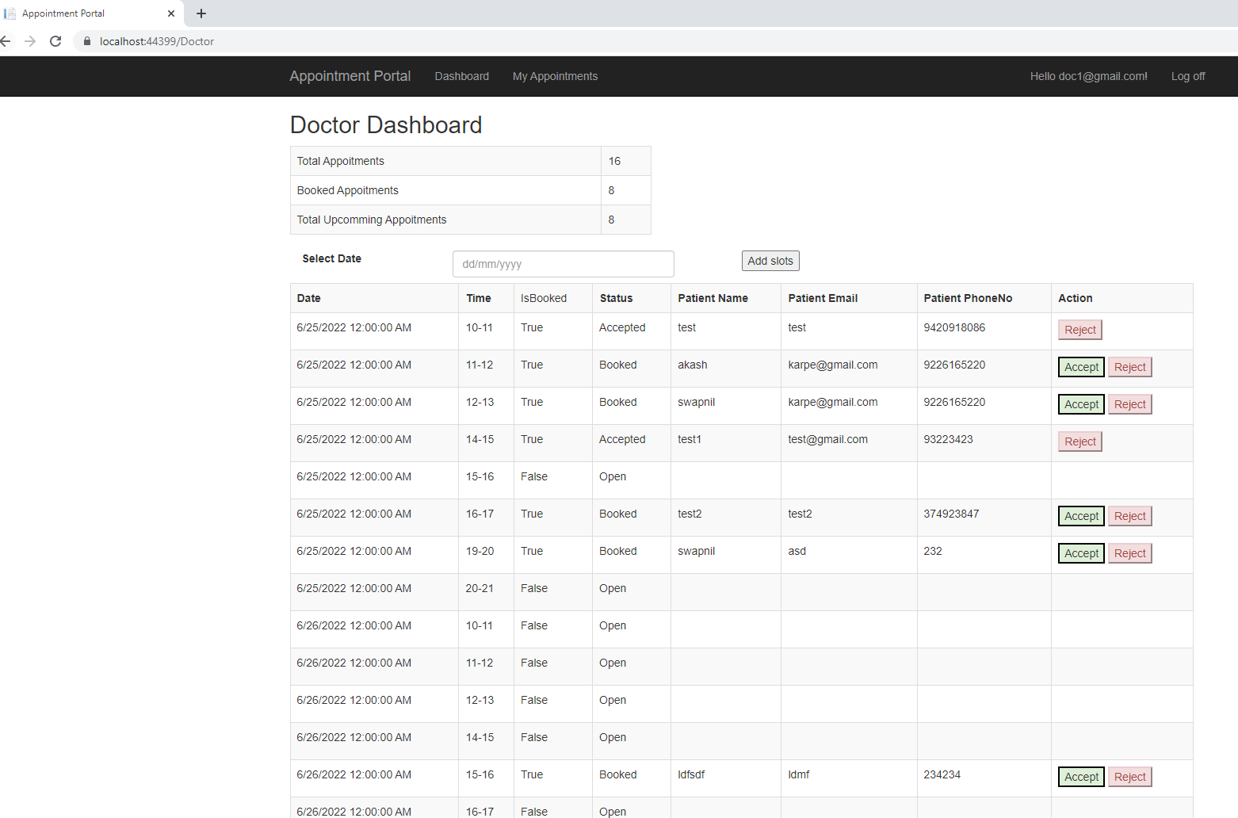

**My Upcoming Appointment Views**

